**Insert School Logo**

**Semester Two Examination 2018**

**Question/Answer Booklet**

**MATHEMATICS**

**METHODS UNITS 3 & 4**

**Section One:**

**Calculator–free**

|  |
| --- |
| Student Name: _____________________________________ |
| Teacher‘s Name: _____________________________________ |
|  |

**Time allowed for this section**

Reading time before commencing work: five minutes

Working time for paper: fifty minutes

**Material required/recommended for this section**

**To be provided by the supervisor**

This Question/Answer booklet

Formula Sheet

**To be provided by the candidate**

Standard items: pens(blue/black preferred), pencils(including coloured), sharpener, correction tape/fluid, erasers, ruler, highlighters

Special Items: nil

**Important note to candidates**

No other items may be taken into the examination room. It is **your** responsibility to ensure that you do not have any unauthorised notes or other items of a non–personal nature in the examination room. If you have any unauthorised material with you, hand it to the supervisor **before** reading any further.

**Structure of this paper**

|  |  |  |  |  |  |
| --- | --- | --- | --- | --- | --- |
|  | Number of questions available | Number of questions to be attempted | Working time (minutes) | Marks available | Percentage of exam |
| **Section One**  **Calculator—free** | **9** | **9** | **50** | **50** | **35** |
| Section Two  Calculator—assumed | 11 | 11 | 100 | 100 | 65 |
|  | | | |  | 100 |

**Instructions to candidates**

1. The rules for the conduct of Western Australian external examinations are detailed in the *Year 12 Information Handbook 2018.* Sitting this examination implies that you agree to abide by these rules.
2. Answer the questions according to the following instructions.

Section One: Write answers in this Question/Answer Booklet. Answer **all** questions.

**Show all your working clearly.** Your working should be in sufficient detail to allow your

answers to be checked readily and for marks to be awarded for reasoning. Incorrect

answers given without supporting reasoning cannot be allocated any marks. For any

question or part question worth more than two marks, valid working or justification is

required to receive full marks. If you repeat an answer to any question, ensure that you

cancel the answer you do not wish to have marked.

It is recommended that you **do not use pencil**, except in diagrams.

1. You must be careful to confine your responses to the specific questions asked and to follow any instructions that are specific to a particular question.
2. Spare pages are included at the end of this booklet. They can be used for planning your responses and/or as additional space if required to continue an answer.

* Planning: If you use the spare pages for planning, indicate this clearly at the top of the

page.

* Continuing an answer: If you need to use the space to continue an answer, indicate in the original answer space where the answer is continued, i.e. give the page number. Fill in the number of the question that you are continuing to answer at the top of the page.

1. The Formula Sheet is **not** handed in with your Question/Answer Booklet.

# Section One: Calculator–free 50 marks

This section has **nine (9)** questions. Attempt **all** questions. Write your answers in the spaces provided.

Spare pages are included at the end of this booklet. They can be used for planning your responses and/or as additional space if required to continue an answer.

* Planning: If you use the spare pages for planning, indicate this clearly at the top of the page.
* Continuing an answer: If you need to use the space to continue an answer, indicate in the original answer space where the answer is continued, i.e. give the page number. Fill in the number of the question(s) that you are continuing to answer at the top of the page.

Working time: 50 minutes

**Question 1 (7 marks)**

Let 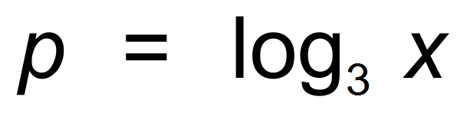.

(a) State the value 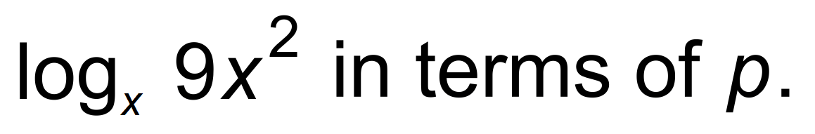 (3 marks)

(b) Evaluate 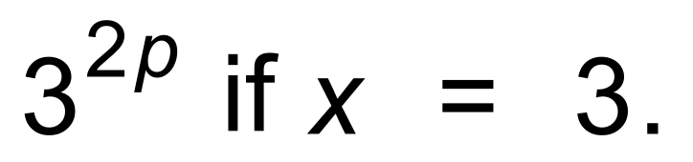 (2 marks)

(c) Evaluate 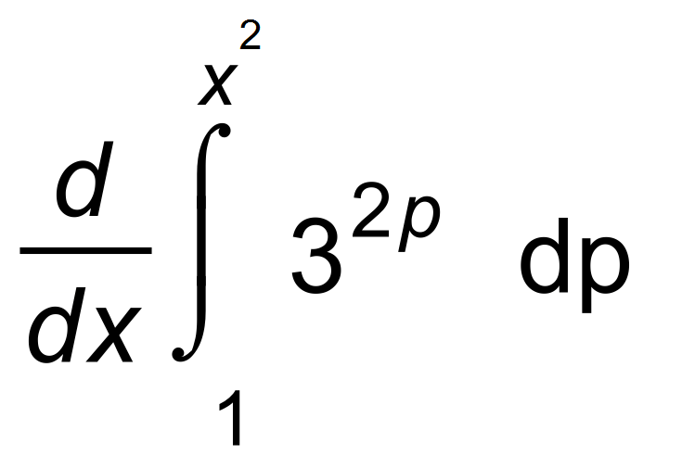 (2 marks)

**Question 2 (8 marks)**

Petra inflates her beach ball. Over the first six seconds, the volume of the ball is

given by 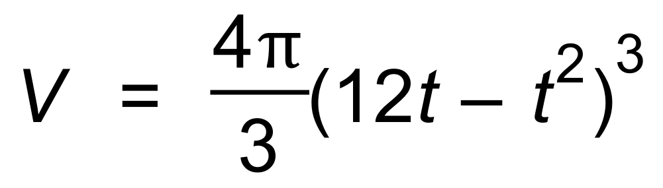.

(a) Use Calculus to determine when the maximum volume is achieved. (4 marks)

(b) (i) Determine the relationship between the radius of the ball ( r ) and t. (2 marks)

(ii) Show that this verifies your answer from (a). (2 marks)

**Question 3 (6 marks)**

Consider the graph of f (x), and the table of values of f (x) for certain x values.

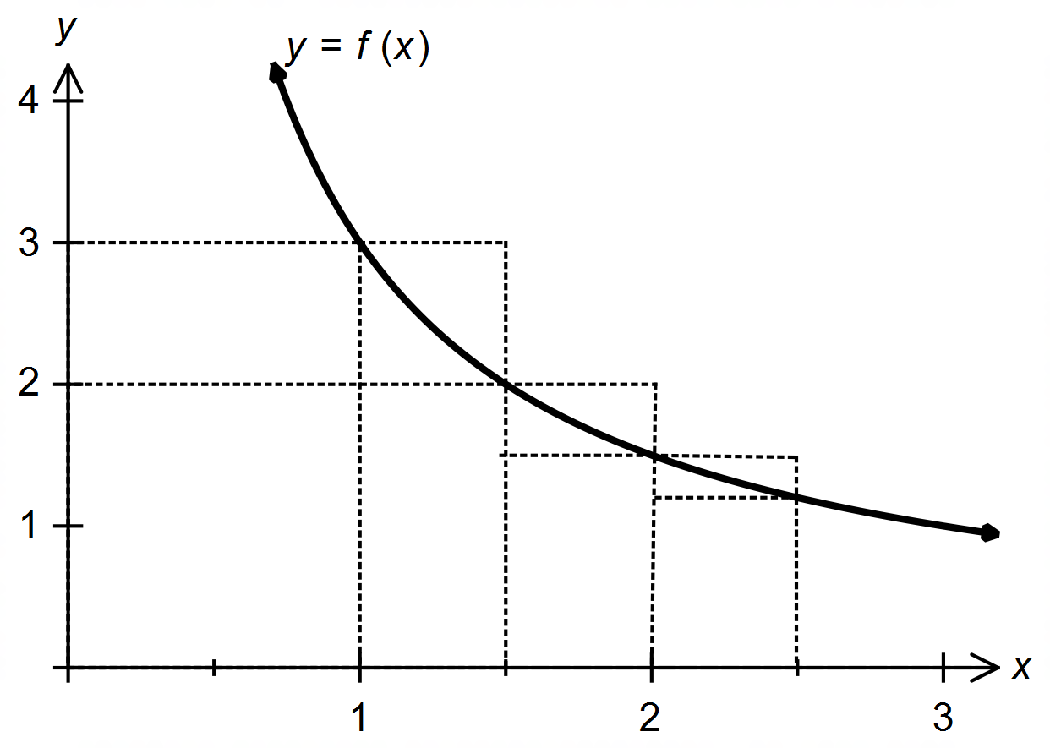

|  |  |  |  |  |
| --- | --- | --- | --- | --- |
| *x* | 1 | 1.5 | 2 | 2.5 |
| *f* (*x*) | 3 | 2 | 1.5 | 1.2 |

(a) By considering the rectangles drawn on the graph, calculate the value of p and q, where:

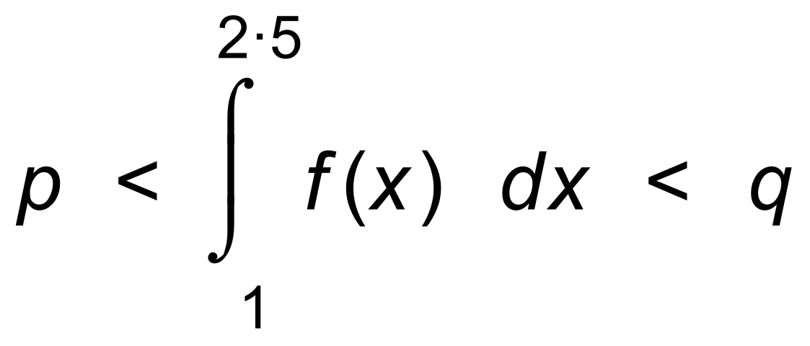 (4 marks)

(b) Given that 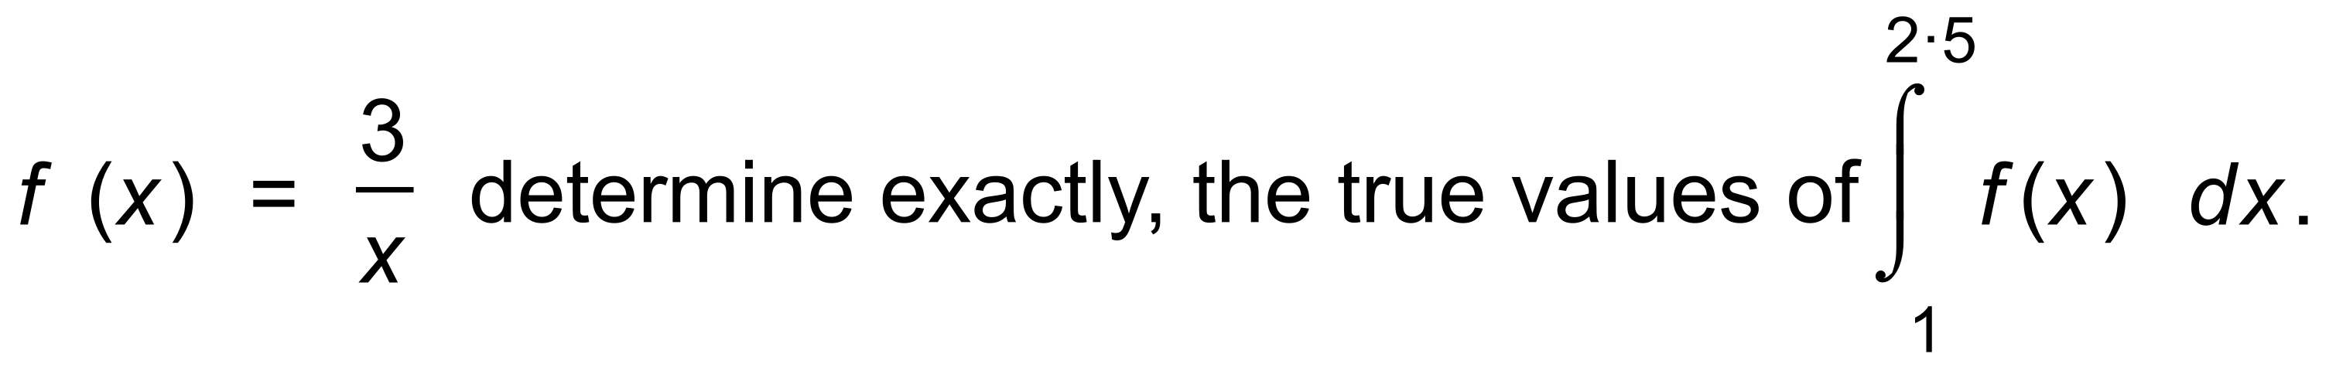 (2 marks)

**Question 4 (5 marks)**

Albert discovered an old die, which wobbled when he rolled it.

He rolled it many times and recorded the results.

The relative frequencies are shown in the histogram as shown.

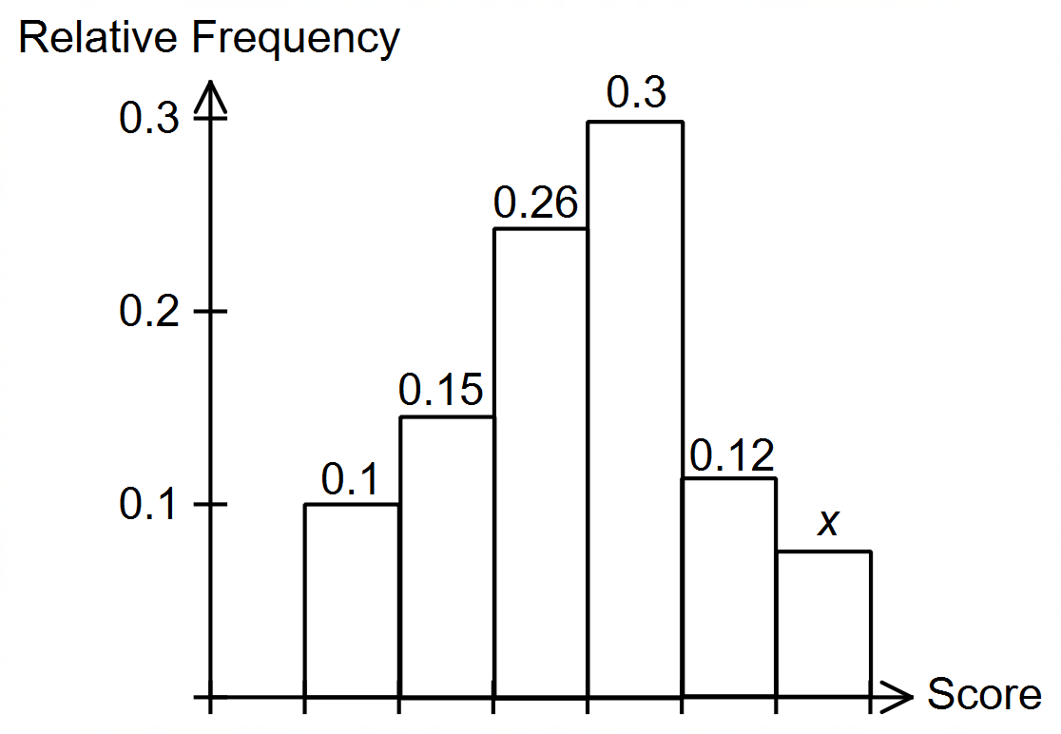

(a) What is the value of x? (1 mark)

(b) What is the probability that the next roll would result in a 1 or a 2? (1 mark)

(c) What is the probability that the next two rolls would both result in a 1 or

both in a result of a 2? (2 marks)

(d) How does this histogram compare with a histogram for an unbiased die? (1 mark)

**Question 5 (6 marks)**

(a) Differentiate 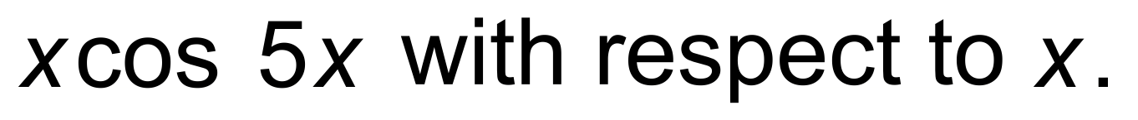 (2 marks)

Hence,

(b) show that 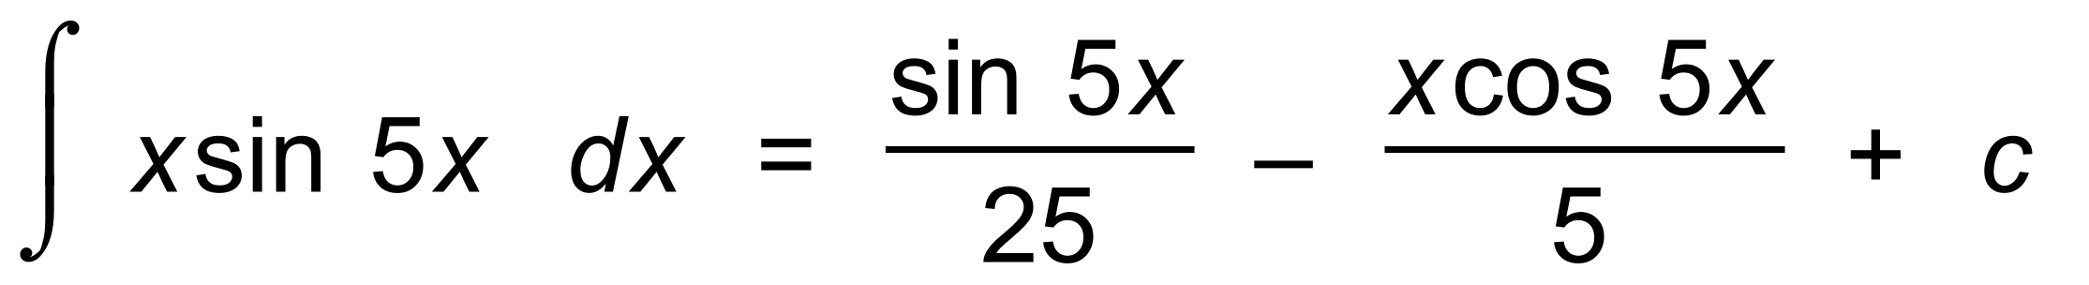 (4 marks)

**Question 6 (5 marks)**

Solve  (5 marks)

**Question 7 (5 marks)**

(a) Sketch the curves 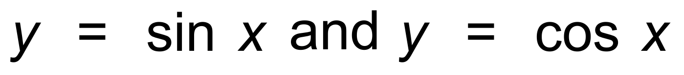 on the axes below, for the

domain given. (2 marks)

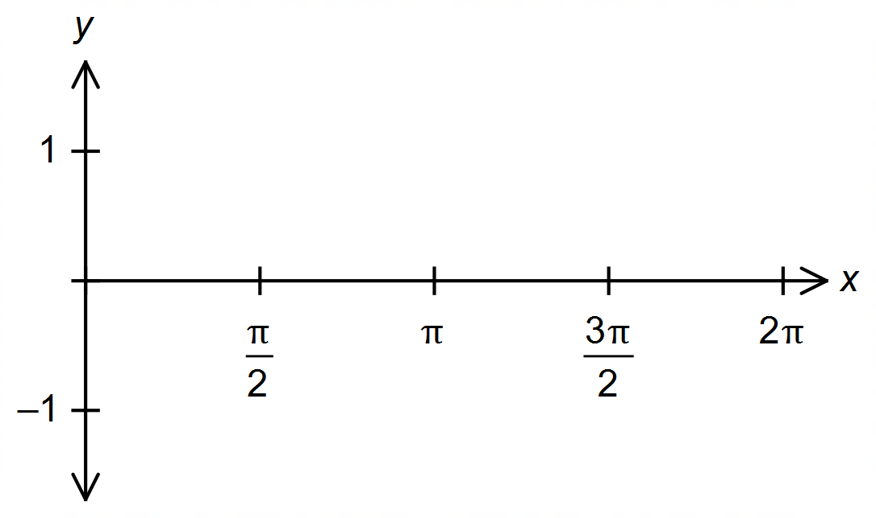

Hence, or otherwise,

(b) determine the area enclosed between the curves between *x* = 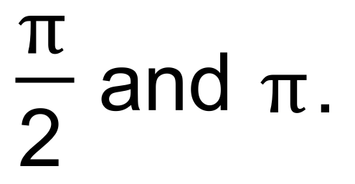 (3 marks)

**Question 8 (3 marks)**

Two independent samples of different sizes were taken from a population.

The first sample had sample size n1, and the second sample had sample size n2,

where 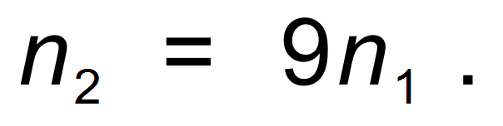

The sample proportions of adults in the samples were the same.

Confidence intervals were calculated for both samples at the 90% level.

Determine the ratio of the two margins of error. That is 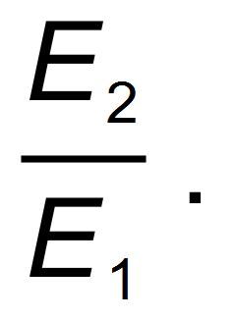 (3 marks)

**Question 9 (5 marks)**

(a) Determine 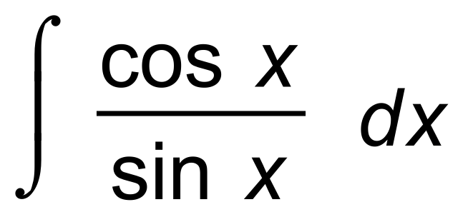 . (2 marks)

Hence, or otherwise,

(b) evaluate 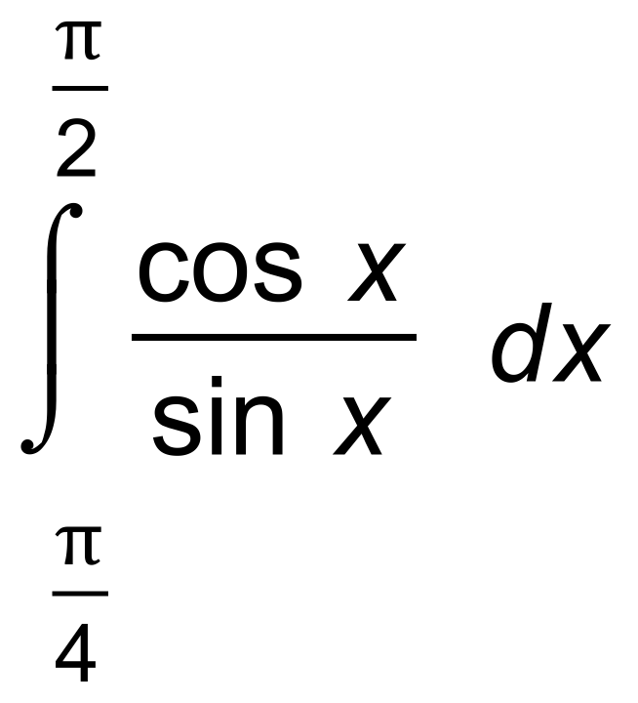 exactly. (3 marks)

**End of Section One**

**Additional working space**

Question number(s): ……………………